Abstract:
deep learning on graphs, which has primarily focused on supervised learning, leading to heavy label reliance, poor generalization, and weak robustness. To overcome these issues, self-supervised learning (SSL) has been introduced. SSL extracts useful knowledge from data through well-designed pretext tasks without relying on manual labels.

The authors present a comprehensive review of the current techniques employing SSL for graph data and formalize the paradigm of graph SSL within a unified framework. They categorize these techniques into four classes based on the objectives of the pretext tasks: generation-based, auxiliary property-based, contrast-based, and hybrid approaches.

Introduction:
Traditional graph structured learning have several drawbacks, including the high cost of label collection and annotation, poor generalization due to overfitting (especially when training data is scarce), and vulnerability to label-related adversarial attacks.

In SSL, models learn from a series of "pretext tasks", where the supervision signals are obtained from the data itself without the need for manual annotation.

Self-supervised learning, deemed by Turing Award winners Yoshua Bengio and Yann LeCun has achieved great success in fields like computer vision and natural language processing. Early SSL methods in these fields involved various semantic-related pretext tasks such as image inpainting, colorizing, and solving jigsaw puzzles. More recent approaches, such as contrastive learning frameworks like MoCo, SimCLR, and BYOL, utilize the invariance of semantics under image transformation to learn visual features. In the domain of NLP, SSL has been successfully employed in pre-training large-scale language models like BERT and XLNet, using linguistic pretext tasks to achieve state-of-the-art performance on multiple NLP tasks.

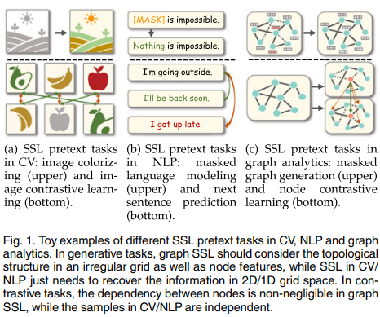

challenging:.Unlike the regular-grid euclidean spaces of image and language data, graphs exist in an irregular, non-euclidean data space, which is more generalized and complex. This complexity makes direct mapping of certain pretext tasks from grid-structured data to graph data impractical. Additionally, while data examples in CV and NLP are often independent, nodes in graph data are inherently interlinked through topological structures.

Graph SSL has roots in early unsupervised graph embedding methods, which learned node representations by focusing on the agreement between contextually close nodes within certain random walks. The graph autoencoder (GAE) is an example of such methods, aiming to reconstruct the graph structure. From 2019 onwards, there has been a surge in graph SSL approaches, introducing diverse pretext tasks ranging from contrastive learning to graph property mining. Given the burgeoning interest in graph SSL and the variety of pretext tasks emerging, there's a pressing need for a unified framework and structured categorization to consolidate the techniques and applications of graph SSL.

comprehensive and current overview of the rapidly evolving field of graph self-supervised learning (SSL). The contributions of this survey are as follows:

1. A unified framework and systematic taxonomy: The paper presents a unified mathematical framework for graph SSL approaches, categorizing existing works into four groups: generation-based, auxiliary property-based, contrast-based, and hybrid methods. It also creates taxonomies of downstream tasks and SSL learning schemes.

2. A comprehensive and up-to-date review: The authors perform a thorough, current review of both classic and recent graph SSL approaches. Each type of graph SSL method is explored in detail, including fine-grained classification, mathematical description, in-depth comparison, and high-level summary.

3. Abundant resources and applications: The paper compiles numerous resources related to graph SSL, such as datasets, evaluation benchmarks, performance comparisons, and open-source codes. It also summarizes the practical applications of graph SSL in various research fields.

4. Future directions: The authors identify the technical limitations of existing research and propose six promising directions for future work from various perspectives.

this paper purely focuses on SSL for graph-structured data. Compared to the recent surveys on graph self-supervised learning, our survey has a more comprehensive overview on this topic and provides the following differences: (1) a unified encoder-decoder framework to define graph SSL; (2) a systematical and more fine-grained taxonomy from a mathematical perspective; (3) more up-todate review; (4) more detailed summary of resources including performance comparison, datasets, implementations, and practical applications; and (5) more forward-looking discussion for challenges and future directions.
Section 2 defines the related concepts and provides notations used in the remaining sections. Section 3 describes the framework of graph SSL and provides categorization from multiple perspectives. Sections 4, 5, 6, and 7 review four categories of graph SSL approaches respectively. Section 8 summarizes the useful resources for empirical study of graph SSL, including performance comparison, datasets, and open-source implementations. Section 9 surveys the real-world applications in various domains. Section 10 analyzes the remaining challenges and possible future directions. Section 11 concludes this article in the end.

definitions and nontation:
1. Manual Labels vs. Pseudo Labels: Manual labels are those that human experts manually annotate, while pseudo labels are those generated automatically by machines without any human intervention.In SSL, specific methods can generate pseudo labels to enhance representation learning.

2. Downstream Tasks vs. Pretext Tasks: Downstream tasks are used to evaluate the quality or performance of the learned feature representation from models. Examples include node classification and graph classification. Pretext tasks, however, are pre-designed tasks for models to solve (like graph reconstruction), which aid the models in learning more generalized representations from unlabeled data. This benefits downstream tasks by providing better initialization or more effective regularization. While downstream tasks typically require manual labels, pretext tasks usually use pseudo labels.

- Supervised Learning, Unsupervised Learning, and Self-Supervised Learning: Supervised learning uses well-defined manual labels to train machine learning models. Unsupervised learning, on the other hand, doesn't use any manual labels. Self-supervised learning, a subset of unsupervised learning, generates supervision signals from the data itself. In self-supervised learning methods, models are trained with pretext tasks to achieve better performance and generalization on downstream tasks.

Notation:
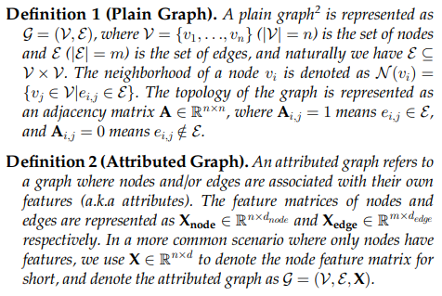
Most of the reviewed methods leverage GNNs as backbone encoders to transform the input raw node features X into compact node representations H by leveraging the rich underlying node connectivity, i.e., adjacency matrix A, with learnable parameters. Furthermore, readout functions R(.) are often employed to generate a graph-level representation hG from node-level representations H. The formulation of GNNs and readout functions are introduced in Appendix B.3, available in the online supplemental material. Besides, in Appendix B.4, available in the online supplemental material, we formulate the commonly used loss functions in this survey.

3.1 Unified Framework and Mathematical Formulation of Graph Self-Supervised Learning
We construct an encoder-decoder framework to formalize graph SSL. The encoder fθ (parameterized by θ) aims to learn a low-dimensional representation (a.k.a. embedding)hi ∈ H for each node vi from graph G. In general, the encoder fθ can be GNNs or other types of neural networks for graph learning . The pretext decoder p∅ (parameterized by ∅) takes H as its input for the pretext tasks. The architecture of p∅ depends on specific downstream tasks.
Under this framework, graph SSL can be formulated as:
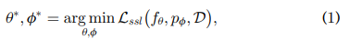

where D denotes the graph data distribution that satisfies in an unlabeled graph G, and Lssl is the SSL loss function that regularizes the output of pretext decoder according to specific crafted pretext tasks.
By leveraging the trained graph encoder fθ* , the generated representations can then be used in various downstream tasks. Here we introduce a downstream decoder qψ (parameterized by ψ), and formulate the downstream task as a graph supervised learning task:
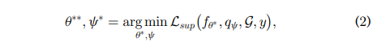
where y denotes the downstream task labels, and Lsup is the supervised loss that trains the model for downstream tasks.In the following subsections, we specify four graph SSL variants based on Equation (1) in Section 3.2, three graph self-supervised training schemes in Section 3.3 by combining Equations (1) and (2) differently, and three types of downstream tasks based on Equation (2) in Section 3.4

3.2 Taxonomy of Graph Self-Supervised Learning
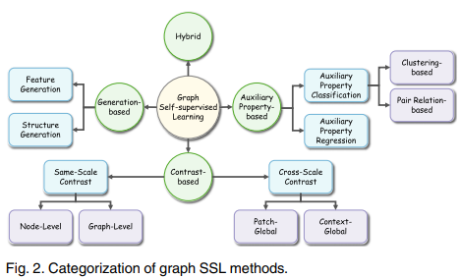
Graph SSL can be divided into four types conceptually,including generation-based, auxiliary property-based, contrastive-based and hybrid methods, by leveraging different designs of pretext decoders and objective functions. The categorizations of these methods are briefly discussed below and shown in Fig. 2, and the concept map of each type of methods is given in Fig. 3.

Generation-based Methods form the pretext task as the graph data reconstruction from two perspectives: feature and structure. Specifically, they focus on the node/edge features or/and graph adjacency reconstructions. In such a case, Equation (1) can be further derived as:
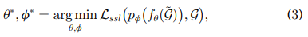
where are graph encoder and pretext decoder. G~ denotes the graph data with perturbed node/edge features or/and adjacency matrix. For most of the generation-based approaches, the self-supervised objective function Lssl is typically defined to measure the difference between the reconstructed and the original graph data. One of the representative approaches is GAE which learns embeddings by rebuilding the graph adjacency matrix.
消除几条边，decoder try to 复原 input graph
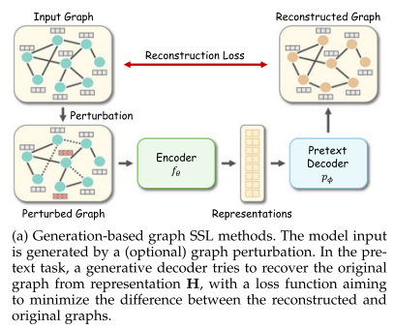
Auxiliary Property-based Methods enrich the supervision signals by capitalizing on a larger set of attributive and topological graph properties. In particular, for different crafted auxiliary properties, we further categorize these methods into two types: regression- and classification-based. Formally, they can be formulated as:
where c denotes the specific crafted auxiliary properties. For regression-based approaches, c can be localized or global graph properties, such as the node degree or distance to clusters within G. For classification-based methods, on the other hand, the auxiliary properties are typically constructed as pseudo labels, such as the graph partition or cluster indices. Regarding to the objective function, Lssl can be mean squared error (MSE) for regression-based and cross-entropy (CE) loss for classification-based methods. As a pioneering work, M3S uses node clustering to construct pseudo labels that provide supervision signals.
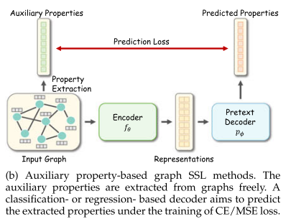

Contrast-based Methods

are usually developed based on the concept of mutual information (MI) maximization, where the estimated MI between augmented instances of the same object (e.g., node, subgraph, and graph) is maximized. For contrastive-based graph SSL, Equation (1) is reformulated as:
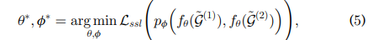

where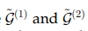 are two differently augmented instances of G. In these methods, the pretext decoder p∅ indicates the discriminator that estimates the agreement between two instances (e.g., the bilinear function or the dot product), and Lssl denotes the contrastive loss. By combining them and optimizing Lssl, the pretext tasks aim to estimate and maximize the MI between positive pairs (e.g., augmented instances of the same object) and minimize the MI between negative samples (e.g., instances derived from different objects), which is implicitly included in Lssl. Representative works include cross-scale methods (e.g., DGI ) and same-scale methods (e.g., GraphCL and GCC 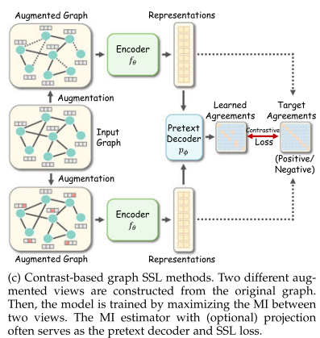

Hybrid Methods take advantage of previous categories and consist of more than one pretext decoder and/or training objective. We formulate this branch of methods as the weighted or unweighted combination of two or more graph SSL schemes based on formulas from Equation (3) to (5). GMI, which jointly considers edge-level reconstruction and node-level contrast, is a typical hybrid method
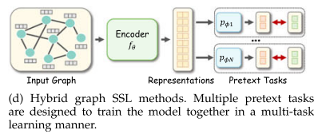

Discussion. Different graph SSL methods have different properties. Generation-based methods are simple to implement since the reconstruction task is easy to build, but sometimes recovering input data is memory-consuming for large-scale graphs. Auxiliary property-based methods enjoy the uncomplicated design of decoders and loss functions; however, the selection of helpful auxiliary properties often needs domain knowledge. Compared to other categories, contrast-based methods have more flexible designs and boarder applications. Nevertheless, the designs of contrastive frameworks, augmentation strategies, and loss functions usually rely on time-consuming empirical experiments. Hybrid methods benefit from multiple pretext tasks, but a main challenge is how to design a joint learning framework to balance each component

3.3 Taxonomy of Self-Supervised Training Schemes

According to the relationship among graph encoders, selfsupervised pretext tasks, and downstream tasks, we investigate three types of graph self-supervised training schemes: Pre-training and Fine-tuning (PF), Joint Learning (JL), and Unsupervised Representation Learning (URL). Brief pipelines of them are given in Fig. 4.

Pre-Training and Fine-Tuning (PF).In PF scheme, the encoder fθ is first pre-trained with pretext tasks on pre-training datasets, which can be viewed as an initialization for the encoder’s parameters. After that, the pre-trained encoder fθinit is fine-tuned together on fine-tuning datasets (with labels) with a downstream decoder qψ under the supervision of specific downstream tasks. Note that the datasets for pre-training and fine-tuning could be the same or different. The formulation of PF scheme is defined as follows:
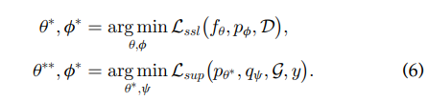
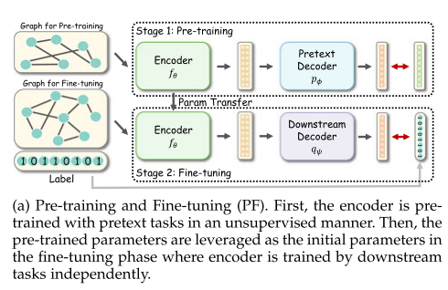

Joint Learning (JL). In JL scheme, the encoder is jointly trained with the pretext and downstream tasks. The loss function consists of both the self-supervised and downstream task loss functions, where a trade-off hyper-parameter a controls the contribution of self-supervision term. This can be considered as a kind of multi-task learning where the pretext task is served as a regularization of the downstream task:
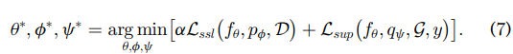
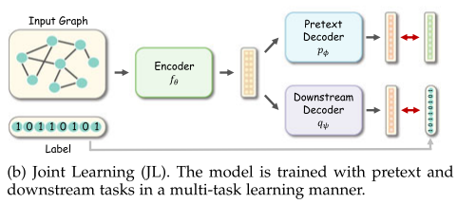

Unsupervised Representation Learning (URL).The first stage of the URL scheme is similar to that of PF. The differences are: (1) In the second stage, the encoder’s parameters are frozen (i.e., theta*) when the model is trained with the downstream task; (2) The training of two stages is performed on the same dataset. The formulation of URL is defined as:
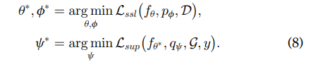
Compared with other schemes, URL is more challenging since there is no supervision during the encoder training.

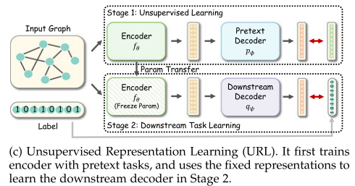
3.4 Taxonomy of Downstream Tasks According to the scale of prediction target, we divide downstream tasks into node-, link-, and graph-level tasks.Specifically, node-level tasks aim to predict the property of nodes in graph(s) according to node representations. Linklevel tasks infer the property of edges or pairs of nodes, where downstream decoders map the embeddings of two nodes into link-level predictions. Besides, graph-level tasks learn from a dataset with multiple graphs and forecast the property of each graph. Based on Equation (2), we provide the specific definitions of downstream decoders qψ, downstream objectives Lsup, and downstream task labels y of three types of tasks, which are detailed in Appendix C, available in the online supplemental material.

4 GENERATION-BASED METHODS
The generation-based methods aim to reconstruct the input data and use the input data as their supervision signals. The origin of this category of methods can be traced back to Autoencoder which learns to compress data vectors into low-dimensional representations with the encoder network and then try to rebuild the input vectors with the decoder network. Different from generic input data represented in vector formats, graph data are interconnected. As a result, generation-based graph SSL approaches often take the full graph or a subgraph as the model input, and reconstruct one of the components, i.e., feature or structure,individually. According to the objects of reconstruction, we divide these works into two sub-categories: (1) feature generation that learns to reconstruct the feature information of graphs, and (2) structure generation that learns to reconstruct the topological structure information of graphs. The pipelines of two example methods are given in Fig. 5, and a summary of the generation-based works is illustrated in Table 1.

4.1 Feature Generation Feature generation approaches learn by recovering feature information from the perturbed or original graphs. Based on Equation (3), the feature generation approaches can be further formalized as: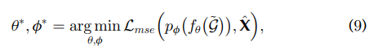
where p∅（.） is the decoder for feature regression (e.g., a fully connected network that maps the representations to reconstructed features), Lmse is the Mean Squared Error (MSE) loss function, and X^ is a general expression of various kinds of feature matrices, e.g., node feature matrix, edge feature matrix, or low-dimensional feature matrix，（G~ denotes the graph data with perturbed node/edge features or/and adjacency matrix） To leverage the dependency between nodes, a representative branch of feature generation approaches follows the
masked feature regression strategy：the features of certain nodes/edges are masked with zero or specific tokens in the pre-processing phase. Then, the model tries to recover the masked features according to the unmasked information. Graph Completion is a representative method： It first masks certain nodes of the input graph by removing their features. Then, the learning objective is to predict the masked node features from the features of neighboring nodes with a GCN encoder.
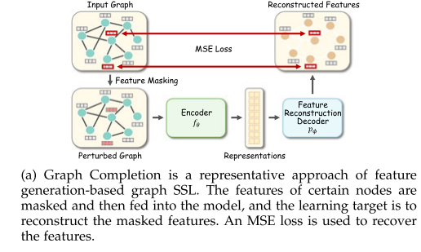 We can we can consider Graph Completion as an implement of Equation (9) where . X is features,Similarly, AttributeMask(A METHOD) aims to reconstruct the dense feature matrix processed by Principle Component Analysis (PCA) instead of the raw features due to the difficulty of rebuilding high-dimensional and sparse features. AttrMasking (ANOTHER METHOD) rebuilds not only node attributes but also the edge one, which can be written as .

Another branch of methods aims to generate features from noisy features. Inspired by denoising autoencoder, MGAE recovers raw features from noisy input features with each GNN layer. Here we also denote but here X~ is corrupted with random noise. Proposed in [45], Corrupted Features Reconstruction and Corrupted Embeddings Reconstruction aim to reconstruct raw features and hidden embeddings from corrupted features.

Besides, directly rebuilding features from the clean data is also an available solution. GALA trains a Laplacian smoothing-sharpening graph autoencoder model with the objective that rebuilds the raw feature matrix according to the clean input graph. Similarly, auto-encoding reconstructs the raw features from clean inputs. For these two methods, we can formalize that and

4.2 Structure Generation
Different from the feature generation approaches that rebuild the feature information, structure generation approaches learn by recovering the structural information. In most cases, the objective is to reconstruct the adjacency matrix, since the adjacency matrix can briefly represent the topological structure of graphs. Based on Equation (3), the structure generation methods can be formalized as follows:
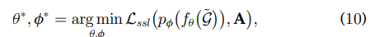
where is a decoder for structure reconstruction, and A is the (full or partial) adjacency matrix. GAE is the simplest instance of the structure generation method. In GAE, a GCN-based encoder first generates node embeddings H from the original graph . Then, an inner production function with sigmoid activation serves as its decoder to recover the adjacency matrix from H. Since adjacency matrix A is usually binary and sparse, a BCE(BINARY CORSS ENTROPY) loss function is employed to maximize the similarity between the recovered adjacency matrix and the original one, where positive and negative samples are the existing edges (Ai;j =1) and unconnected node pairs (Ai;j = 0), respectively. To avoid the imbalanced training sample problem caused by extremely sparse adjacency, two strategies can be used to prevent trivial solution: (1) re-weighting the terms with Ai;j = 1; or (2) sub-sampling terms with Ai;j = 0.

As a classic learning paradigm, GAE has a series of derivative works. VGAE further integrates the idea of variational autoencoder into GAE. It employs an inference model-based encoder that estimates the mean and deviation with two parallel output layers and uses Kullback-Leibler divergence between the prior distribution and the estimated distribution. Following VGAE, SIG-VAE considers hierarchical variational inference to learn more generative representations for graph data. ARGA/ARVGA regularizes the GAE/VGAE model with generative adversarial networks (GANs) . Specifically, a discriminator is trained to distinguish the fake and real data, which forces the distribution of latent embeddings closer to the Gaussian prior. SuperGAT further extends this idea to every layers in the encoder. Concretely, it rebuilds the adjacency matrix from the latent representations of every layer in the encoder. Instead of rebuilding the full graph, another solution is to reconstruct the masked edges.

Denoising Link Reconstruction
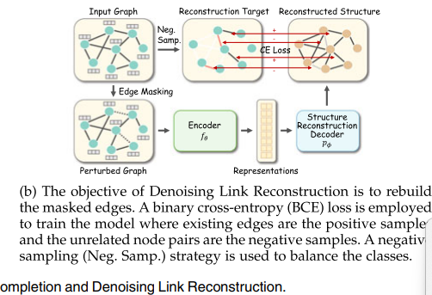
IT randomly drops existing edges to obtain the perturbed graph G~. Then, the model aims to recover the discarded connections with a pairwise similarity-based decoder trained by a BCE loss. EdgeMask also has a similar perturbation strategy, where a non-parametric MAE function minimizes the difference between the embeddings of two connected nodes. Zhu et al. [51] apply two perturbing strategies, i.e., Randomly Removing Links and Randomly Covering Features, to the input graph , while its target is to recover the masked link by a decoder.

Discussion. Due to the different learning targets, two branches of generation-based methods have distinct designs of the decoder and loss functions. The learned representations by structure generation usually contain more node pair-level(A) information since structure generation focuses on edge reconstruction; by contrary, feature generation methods often capture node-level knowledge。

5 AUXILIARY PROPERTY-BASED METHODS
These methods have a similar training paradigm with supervised learning since both of them learn with “sample-label” pairs. Their difference lies in how the label is obtained: In supervised learning, the manual label is human-annotated which often needs expensive costs; in auxiliary property-based SSL, the pseudo label is self-generated automatically without any cost.we divide auxiliary property-based methods into two subcategories: (1) auxiliary property classification which leverages classification-based pretext tasks to train the encoder and (2) auxiliary property regression which performs SSL via regression-based pretext tasks.

5.1 Auxiliary Property Classification Borrowing the training paradigm from supervised classification tasks, the methods of auxiliary property classification create discrete pseudo labels automatically, build a classifier as the pretext decoder, and use a cross entropy (CE) loss Lce to train the model. Originated from Equation (4), we provide the formalization of this branch of methods as;
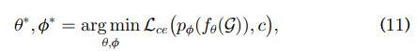
where p∅ is the neural network classifier-based decoder which outputs a k-dimensional probability vector (k is the number of classes), and is the corresponding pseudo label which belongs to a discrete and finite label set C. According to the definition of pseudo label set C, we further construct two sub-categories under auxiliary property classification, i.e., clustering-based and pair relation-based methods.
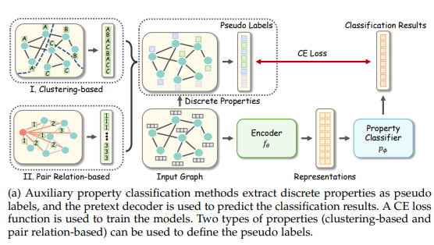
5.1.1 Clustering-Based Methods
A promising way to construct pseudo label is to divide nodes into different clusters according to their attributive or structural characteristics. To achieve that, a mapping function Ω : V->C is introduced to acquire the pseudo label for each node, which is built on specific unsupervised clustering/partitioning algorithms. Then, the learning objective is to classify each node into its corresponding cluster. Following Equation (11), the learning objective is refined as:
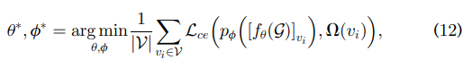

where [.]vi is the picking function that extracts the representation of vi.

Node Clustering is a representative approach that utilizes attributive information to generate pseudo labels. Specifically, it leverages a feature-based clustering algorithm (which is an instance of Ω) taking X as input to divide node set into k clusters, and each cluster indicates a pseudo label for classification. The intuition behind Node Clustering is that nodes with similar features tend to have consistent semantic properties. M3S [40] introduces a multi-stage self-training mechanism for SSL using DeepCluster [61] algorithm. In each stage, it first runs K-means clustering on node embedding H. After that, an alignment is executed to map each cluster to a class label. Finally, the unlabeled nodes with high confidence are given the corresponding (pseudo) labels and used to train the model. In M3S, C is borrowed from the manual label set Y, and Ω is composed of the K-means and alignment algorithms. In addition to feature-based clustering, Graph Partitioning divides the nodes according to the structural characteristics of nodes. Concretely, it groups nodes into multiple subsets by minimizing the connections across subsets, defining Ω as the graph partitioning algorithm. Cluster Preserving [50] first leverages graph clustering algorithm to acquire non-overlapping clusters, and then calculates the representation of each cluster via an attention-based aggregator. After that, a vector representing the similarities between each node and the cluster representations is assigned as the soft pseudo label for each node. Besides, CAGNN [56] first runs feature-based clusters to generate pseudo labels and then refines the clusters by minimizing inter-cluster edges, which absorbs the advantages of both attributive and structural clustering algorithms。

5.1.2 Pair Relation-Based Methods
Apart from the clustering and graph properties, an alternative supervision signal is the relationship between each pair of nodes within a graph. In these methods, the input of the decoder is not a single node or graph but a pair of nodes. A mapping function Ω : V x V -> C is utilized to define the pseudo label according to pair-wise contextual relationship. We write the objective function as:
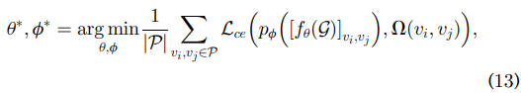
Where is the node pair set defined by specific pretext tasks, and is the picking function that extracts and concatenates the node representations of vi and vj. Some approaches regard the distance between two nodes as the auxiliary property. For instance, S2GRL learns by predicting the shortest path between two nodes. Specifically, the label for a pair of nodes is defined as the shortest distance between them. Formally, we can write the mapping function as . The decoder is built to measure the interaction between pairs of nodes, which is defined as an element-wise distance between two embedding vectors. The node pair set P collects all possible node pairs including the combination of all nodes with their 1 to K hops neighborhoods. PairwiseDistance has a very similar learning target and decoder with S2GRL, but introduces an upper bound of distance, which can be represented as . Centrality Score Ranking presents a pretext task that predicts the relative order of centrality scores between a pair of nodes. For each node pair , it first calculates four types of centrality scores si; sj (eigencentrality, betweenness, closeness, and subgraph centrality), and then creates its pseudo label by comparing the value of si and sj. We formalize the mapping function as: , where is the identity function。

5.2 Auxiliary Property Regression
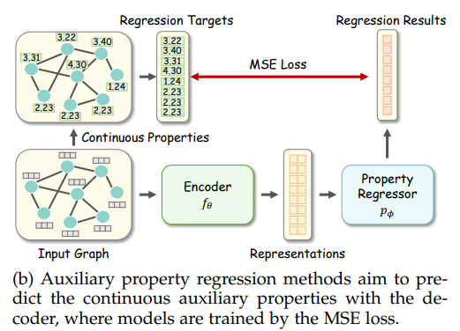
Auxiliary property regression approaches construct the pretext tasks on predicting extensive numerical properties of graphs. Compared to auxiliary property classification, the most significant difference is that the auxiliary properties are continuous values within a certain range instead of discrete pseudo labels in a limited set. We refine Equation (4) into a regression version:
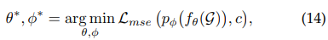
where Lmse is the MSE loss function for regression, and c ∈ R is a continuous property value. NodeProperty [43] is a node-level pretext task that predicts the property for each node. The available choices of node properties include their degree, local node importance, and local clustering coefficient. Taking node degree as an example, the objective function is illustrated as follows:

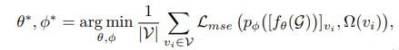

where Ω(vi) = Pn j=1 Aij is the mapping function that calculates the degree of node vi . Distance2Cluster [43] aims to regress the distances from each node to predefined graph
Discussion. As we can observe, the auxiliary property classification methods are more diverse than the regression methods, since the discrete pseudo labels can be acquired by various algorithms. In future works, more continuous properties are expected to be leveraged for regression methods

6 CONTRAST-BASED METHODS
The contrast-based methods are built on the idea of mutual information (MI) maximization , which learns by predicting the agreement between two augmented instances. Specifically, the MI between graph instances with the similar semantic information (i.e., positive samples) is maximized, while the MI between those with unrelated information (i.e., negative samples) is minimized. Similar to the visual domain , there exist various graph augmentations and contrastive pretext tasks on multiple granularities to enrich the supervision signals. Following the taxonomy of contrast-based graph SSL defined in Section 3.2.3, we survey this branch of methods from three perspectives: (1) Graph augmentations that generate various graph instances; (2) Graph contrastive learning which forms various contrastive pretext tasks on the nonEuclidean space; (3) Mutual information estimation that measures the MI between instances and forms the contrastive learning objective together with specific pretext tasks.

6.1 Graph Augmentations
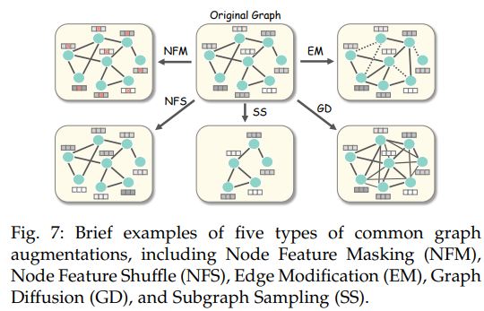
Recent success of contrastive learning on the visual domain relies heavily on well-crafted image augmentations, which reveals that data augmentations benefit the model to explore richer underlying semantic information by making pretext tasks more challenging to solve [67]. However, due to the nature of graph-structured data, it is difficult to apply the augmentations from the Euclidean to the non-Euclidean space directly. Motivated by image augmentations (e.g., image cutout and cropping [24]), existing graph augmentations can be categorized into three types: attributive-based, topological-based, and the combination of both (i.e.hybrid augmentations). The examples of five representative augmentation strategies are demonstrated in Fig. 7. Formally, given a graph G, we define the i-th augmented graph instance as G˜(i) = ti(G), where ti ∼ τ is a selected graph augmentation and τ is a set of available augmentations.
6.1.1 Attributive augmentations:Node feature masking (NFM),node feature shuffle (NFS)
6.1.2 Topological augmentations:edge modification (EM),, graph diffusion (GD)
6.1.3 Hybrid augmentations:Subgraph sampling (SS)

6.2 Graph Contrastive Learning
As contrastive learning aims to maximize the MI between instances with similar semantic information, various pretext tasks can be constructed to enrich the supervision signals from such information. Regarding the formulation of pretext decoder pφ(·) in Equation (5), we classify existing works into two mainstreams: same-scale and cross-scale contrastive learning. The former branch of methods discriminates graph instances in an equal scale (e.g., node versus node), while the second type of methods places the contrasting across multiple granularities (e.g., node versus graph). Fig. 8 and Table 3 provide the pipelines and summaries of contrastbased methods, respectively.
6.2.1 Same-Scale Contrast According to the scale for contrast, we further divide the same-scale contrastive learning approaches into two subtypes: node-level and graph-level
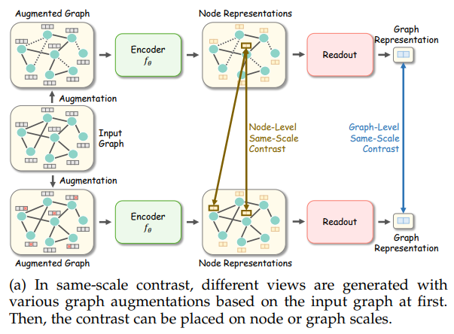
Node-Level Same-Scale Contrast: In other word, these methods are trying to pull the representation of a node closer to its contextual neighborhood without relying on complex graph augmentations.the idea is that nodes with similar contextual information should share the similar representations

Graph-Level Same-Scale Contrast: For graphlevel representation learning under same-scale contrasting, the discrimination is typically placed on graph representations
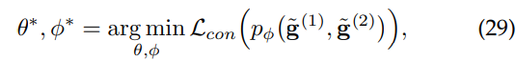
where 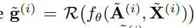denotes the representation of augmented graph G˜(i) , and R(·) is a readout function to generate the graph-level embedding based on node representations.

6.2.2 Cross-Scale Contrast Different from contrasting graph instances in an equivalent scale, this branch of methods places the discrimination across various graph topologies (e.g., node versus graph). We further build two sub-classes under this category, namely patch-global and context-global contrast.
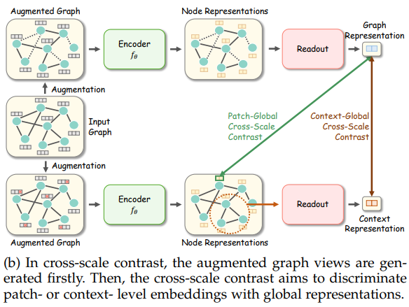
6.2.2.1 Patch-Global Cross-Scale Contrast:
For nodelevel representation learning, we define this contrast as below:
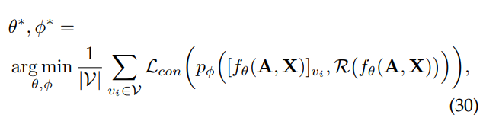
where R(·) denotes the readout function as we mentioned in previous subsection. Under this category, DGI [13] is the first method that proposes to contrast node-level embeddings with the graph-level representation, which aims to maximize the MI between such two representations from different scales to assist the graph encoder to learn both localized and global semantic information.

6.2.2.2 Context-Global Cross-Scale Contrast:
Another popular design under the category of cross-scale graph contrastive learning is context-global contrast, which is defined below:
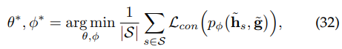
where S denotes a set of contextual subgraphs in an augmented input graph G˜, where augmentations are typically based on graph sampling under this category. In above formula, h˜ s is the representation of augmented contextual subgraph s, and g˜ represents the graph-level representation over all subgraphs in S.

6.3 Mutual Information Estimation
Most of contrast-based methods rely on the MI estimation between two or more instances. Specifically, the representations of a pair of instances sampled from the positive pool are being pulled closer while the counterparts from negative sets are pushed away. Given a pair of instances (xi , xj ), we let (hi , hj ) to denote their representations. Thus, the MI between (i, j) is given by:
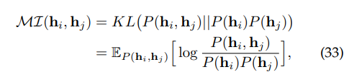
where KL(·) denotes the Kullback-Leibler divergence, and the end goal is to train the encoder to be discriminative between a pair of instances from the joint density P(hi , hj ) and negatives from marginal densities P(hi) and P(hj ).In this subsection, we define two common forms of lower bound and three specific forms of non-bound MI estimators derived from Equation (33).

Discussion. In general, same-scale methods usually follow the two-stream contrastive learning frameworks (e.g., SimCLR [24] and BYOL [25]), where InfoNCE and BYOL losses are widely used; In contrast, cross-scale methods often derive from DGI [13], hence they prefer the JSD loss

7 HYBRID METHODS
Compared to the aforementioned methods that only utilize a single pretext task to train models, hybrid methods adopt multiple pretext tasks to better leverage the advantages of various types of supervision signals. The hybrid methods integrate various pretext tasks together in a multi-task learning fashion, where the objective function is the weighted sum of two or more self-supervised objectives. The formulation of hybrid graph SSL methods is:
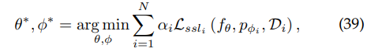

where N is the number of pretext tasks, αi , Lssli , pφ1 and Di are the trade-off weight, loss function, pretext decoder and data distribution of the i-th pretext task, respectively。

8 empirical study
The study compares representative methods on two tasks: node classification and graph classification. For performance evaluation in node classification, three citation network datasets (Cora, Citeseer, and Pubmed) and the PPI dataset were used.

Two groups of graph SSL methods were compared: URL and PF/JL. In the URL group, the encoder was trained solely by SSL pretext tasks, and the learned representations were directly fed into classification decoders. In contrast, the PF/JL group had access to training labels for encoders’ learning. The study also compared semi-supervised Graph Convolutional Networks (GCN) and Graph Attention Networks (GAT) as baselines.

The findings of the study are as follows:

1. Early contrastive and generative methods like DeepWalk, GraphSAGE, GAE, and SIG-VAE performed worse than most graph SSL methods, possibly due to their reliance on simple unsupervised learning targets instead of well-designed self-supervised pretext tasks.

2. Methods using advanced contrastive objectives from visual contrastive learning (e.g., BGRL using BYOL loss and GBT using Barlow Twins loss) did not exhibit superior performance, indicating that self-supervised objectives from other domains don't always enhance performance.

3. Some contrast-based methods, such as MVGRL, MERIT, and SubGCon, outperformed generalization-based and auxiliary property-based methods, highlighting the effectiveness of contrastive pretext tasks.

4. Hybrid methods performed competitively, with some even outperforming the supervised baselines, suggesting that the integration of multiple pretext tasks can provide diverse supervision signals, thereby improving performance.

5. The performance of methods in the PF/JL group was generally better than that of the URL group, demonstrating the benefit of having access to label information for graph SSL.

The study also provides additional resources for the evaluation and performance comparison of graph classification, benchmark datasets, and open-source implementations of the surveyed works. These resources are detailed in Appendices D, E, and F, respectively, and are meant to facilitate further research.

